**LAB#05**

# **Task#01:**

## **Code:**

#!/bin/bash  
  
echo "Enter numbers"  
read num1  
read num2  
read num3  
echo "Sum = "$(expr $num1 + $num2 + $num3)  
a=0  
b=$(expr $num1 + $num2 + $num3)  
for((i=2; i>0; i--))  
do  
c=$(expr $b % 10)  
b=$(expr $b / 10)  
a=$(expr $a \* 10 + $c)  
done

echo "Reverse = "$a

## **Output:**

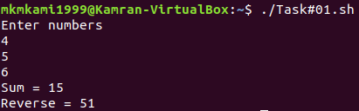

# **Task#02:**

## **Code:**

#!/bin/bash

echo "Enter number = $num"

read num

for counter in {1..10}

do

echo "$num*$counter="$(expr $num \* $counter)

done

## **Output:**

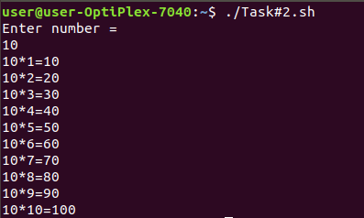

# **Task#03:**

## **Code:**

#!/bin/bash

echo "Enter a number:"

read num

if(($num>0))

then

echo "The number is positive"

elif(($num<0))

then

echo "The number is negative"

elif(($num==0))

then

echo "The number is equal to zero"

else

echo "Invalid Input!!!"

fi

## **Output:**

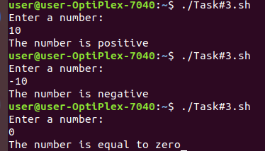

# **Task#04:**

## **Code:**

#!/bin/bash

for counter in {1..10}

do

echo "K a M i"

done

## **Output:**

